Tab 1
Selfpaced is a feature used by students to learn independently on the Cakap LMS. Through this feature, students can access learning materials, complete lessons, and obtain a certificate after finishing the course requirements. Selfpaced learning allows students to study anytime and at their own pace without depending on a fixed schedule.
There are five types of classes available in Selfpaced:
- Single Test – A class that only consists of a test or assessment without learning materials. It is usually used to evaluate a student's knowledge or skills.
- Async Class (Asynchronous Class) – A class where students can access recorded materials, videos, and other learning resources anytime without real-time interaction with a teacher.
- Sync Class (Synchronous Class) – A class that includes live sessions with a teacher at a scheduled time, allowing real-time interaction between students and instructors.
- Class Placement Test – A test designed to determine a student's proficiency level so they can be placed in the most appropriate class.
- Kids Class – A class specifically designed for children, with materials and learning approaches tailored to younger learners.

First, we need to create the class in the admin system. After the class is created, it will be available in the Selfpaced LMS for students to access. Students can then enrol (buy/redeem)l in the class, access the learning materials, complete the lessons or tests provided, and receive a certificate once they meet the course requirements.

Admin Course Single Test
Sample course : DISC Personality Test Widi
- Go to menu selfpaced -> General -> Add new Single Test Course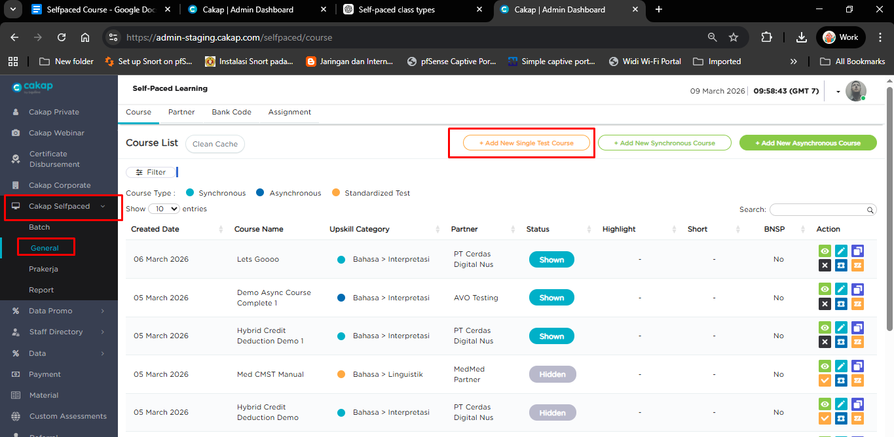
- Fill in all required fields in the Marketplace form.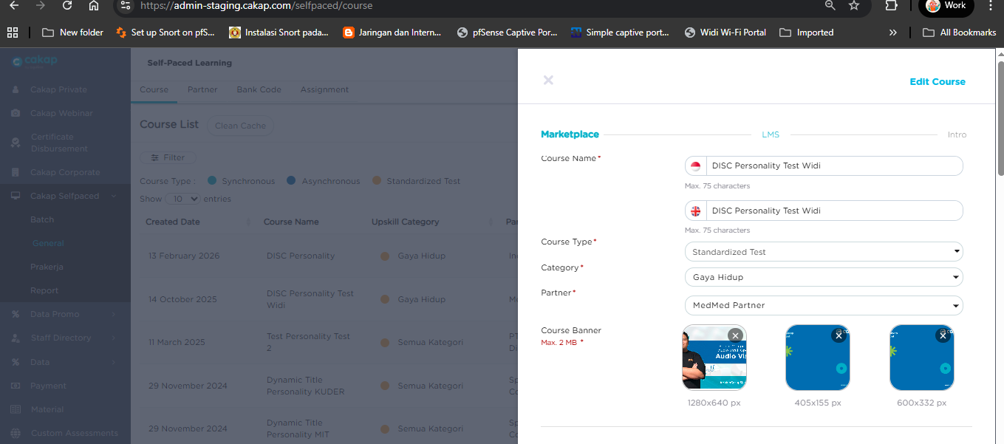
- Fill in all required fields in the LMS form, Get the assessment link from menu assessment (can ask assassins team).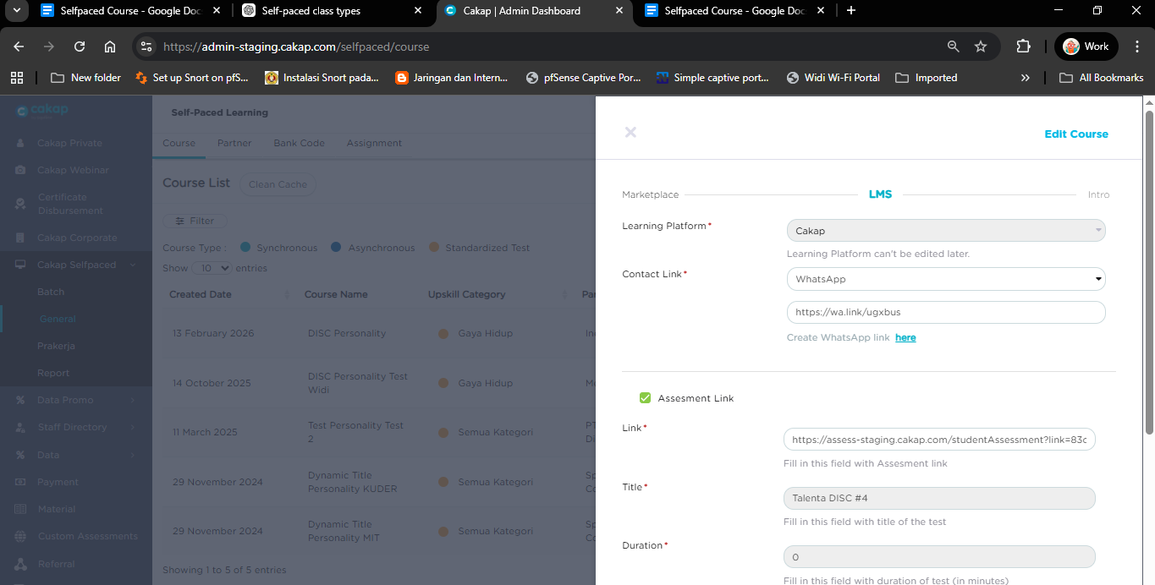
- After all required fields are filled in, click Save to create the Single Test course. ✅
Admin Course Asynchronous Course
Sample course : Demo Async Course Complete 1
- Go to menu selfpaced -> General -> Add new Asynchronous Course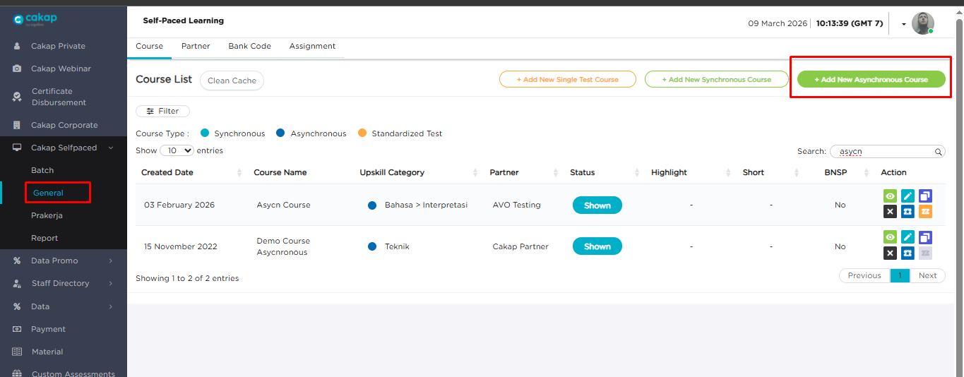
- Fill in all required fields in the Marketplace form.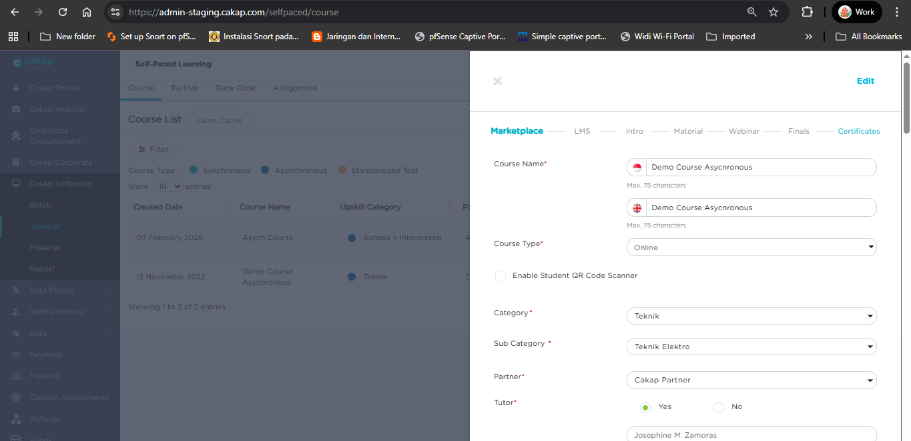
- Fill in all required fields in the LMS form. Don’t forget to check the Learning Content settings. Not has access Full Access in async, only choose Sequential so students must finish the previous material before accessing the next one. 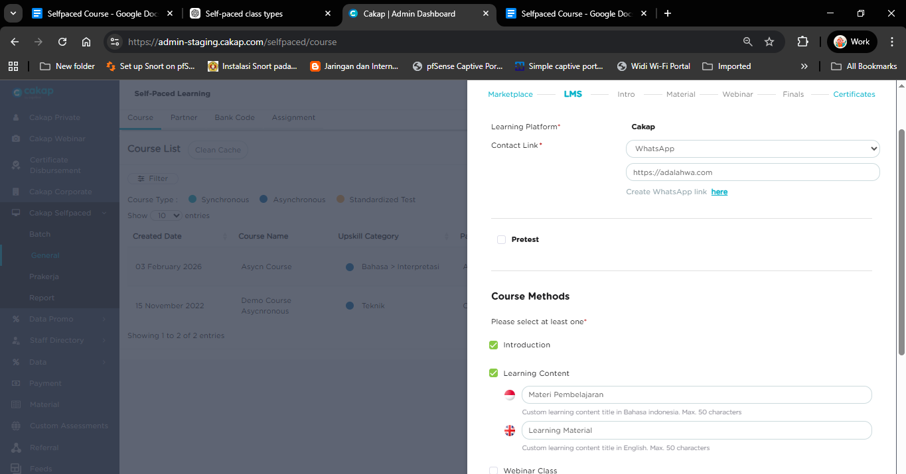
- Upload an intro video if the Intro option is selected.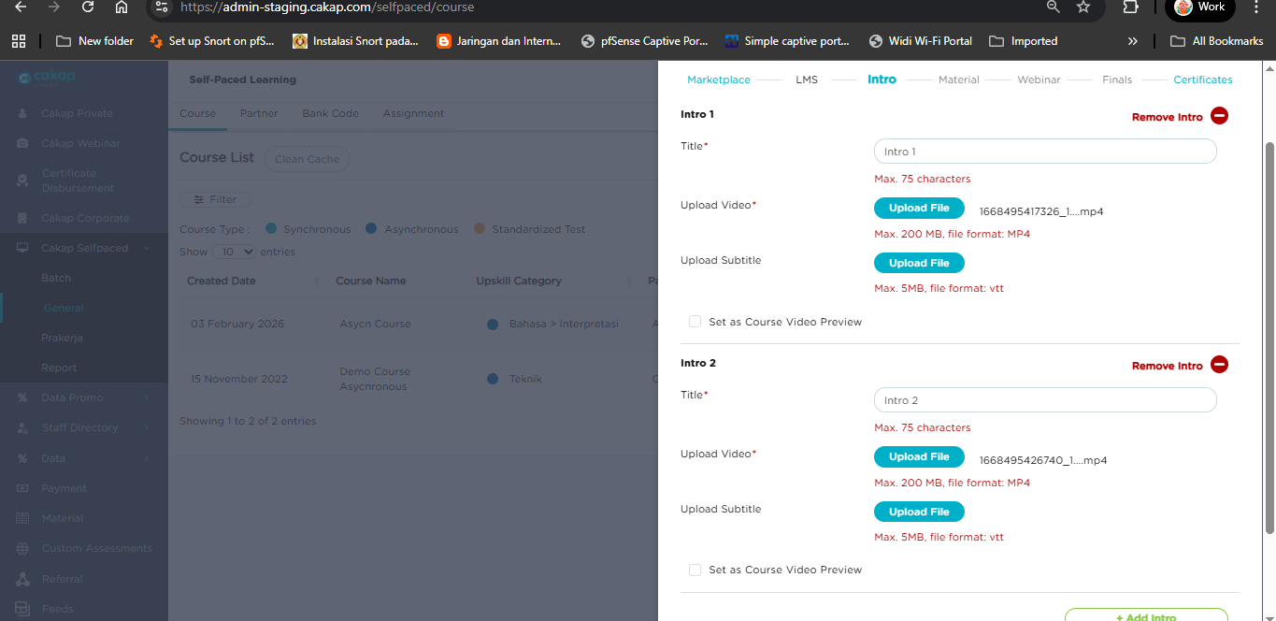
- Upload all learning materials in this menu. You can refer to the materials that have been uploaded in this component.Banner Data Selfpaced [Testing]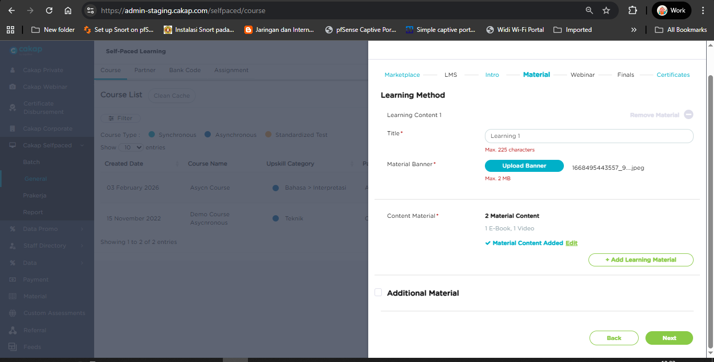
- Fill in the form with the final test data. You can refer to the existing data as a reference. You can also select a certificate so that users will receive a certificate after finishing the course.Banner Data Selfpaced [Testing]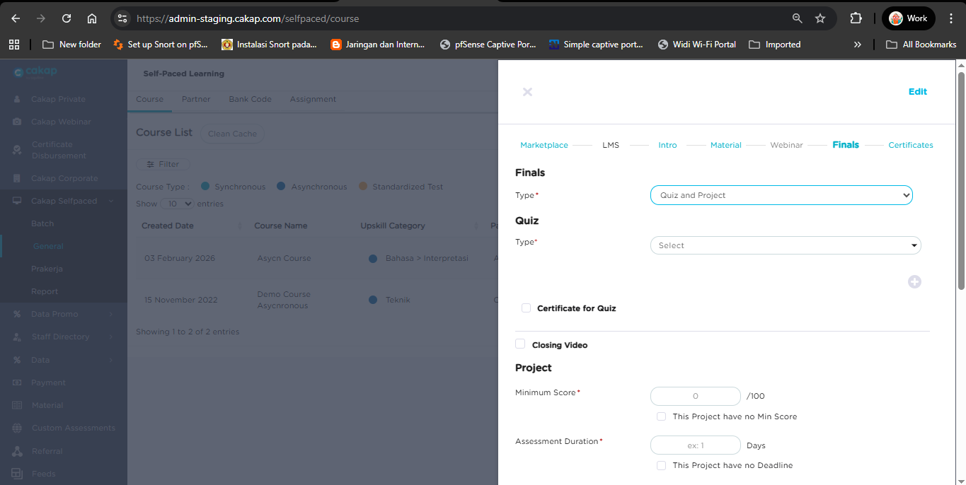
- In the Certificate tab, just fill it with “-” because it is no longer used. After all sections are completed, click Save and the Async course will be created.✅
Admin Course Synchronous Course
Sample course : Course Revamp Very Complete
- Go to menu selfpaced -> General -> Add new Synchronous Course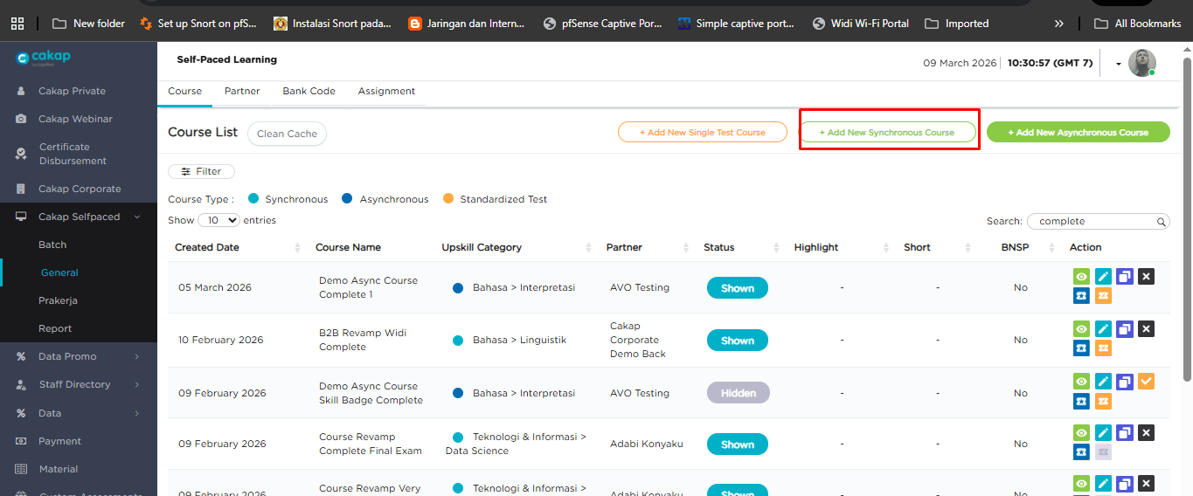
- Fill in all required fields in the Marketplace form.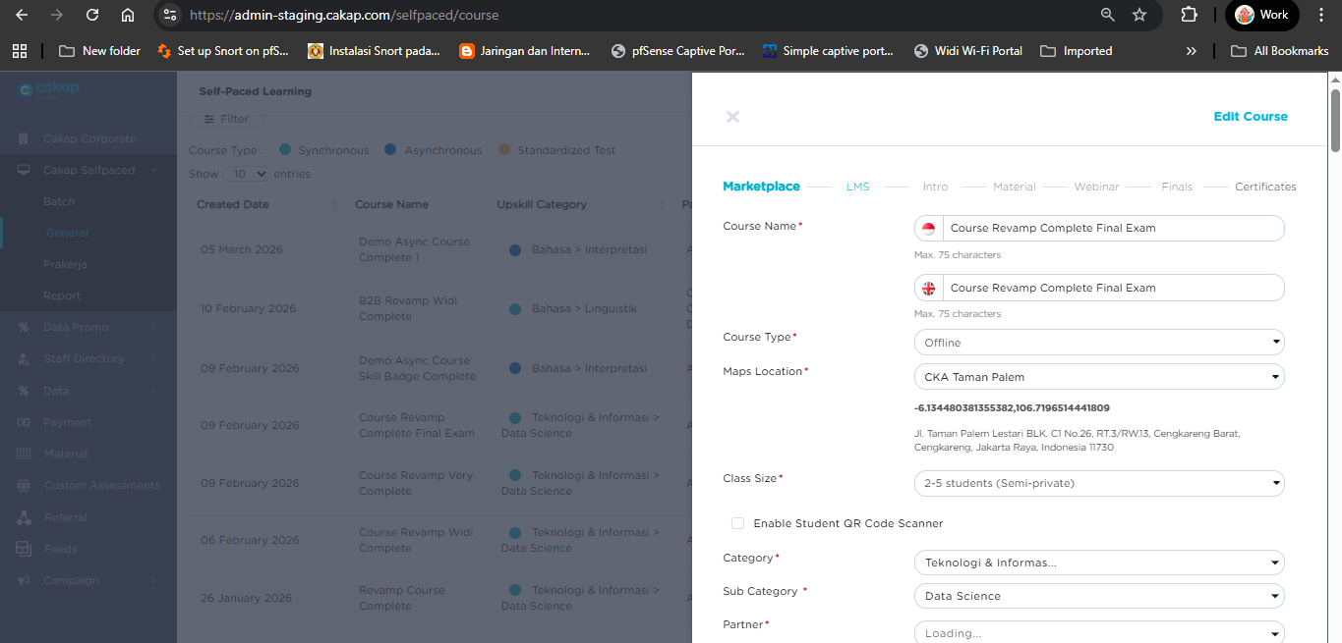
- Fill in all required fields in the LMS form. Don’t forget to check the Learning Content settings. Choose Full Access to allow students to open all materials without completing the previous ones, or choose Sequential so students must finish the previous material before accessing the next one.
- Upload an intro video if the Intro option is selected.
- Upload all learning materials in this menu. You can refer to the materials that have been uploaded in this component.Banner Data Selfpaced [Testing]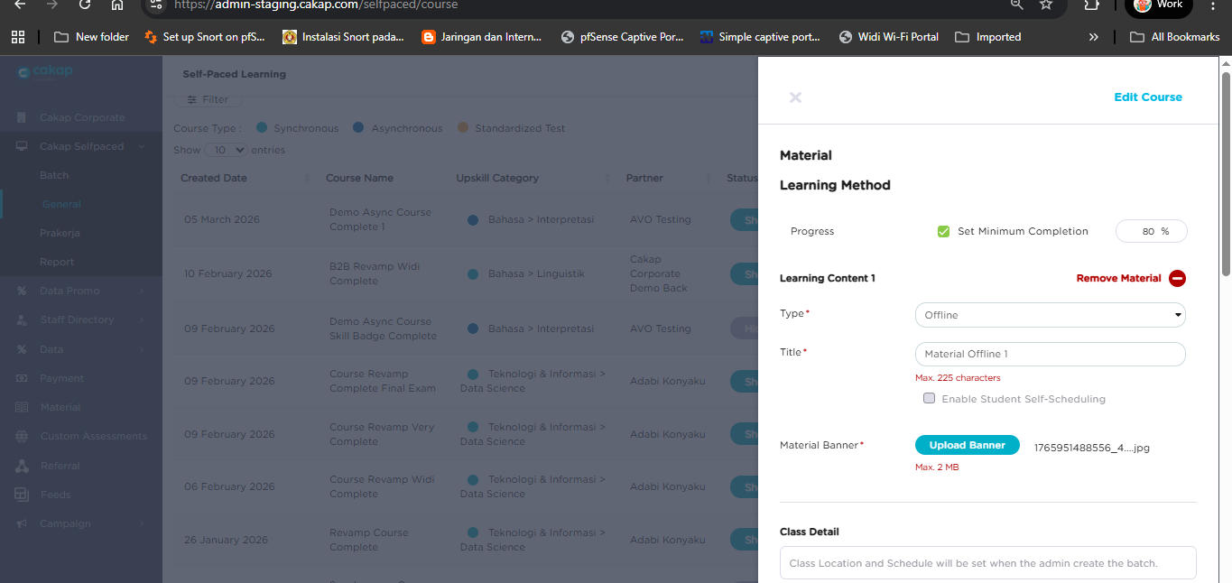
- Fill in the form with the final test data. You can refer to the existing data as a reference. You can also select a certificate so that users will receive a certificate after finishing the course.Banner Data Selfpaced [Testing]
- In the Certificate tab, just fill it with “-” because it is no longer used. After all sections are completed, click Save and the Async course will be created.✅

Admin Course Placement Test
Sample course : Demo Placement Test for Kids Happy
- The method for creating the course is the same as the flow for creating an Admin Synchronous Course. The only difference is in the Marketplace section, where you need to select “Connect Assessment” as shown below.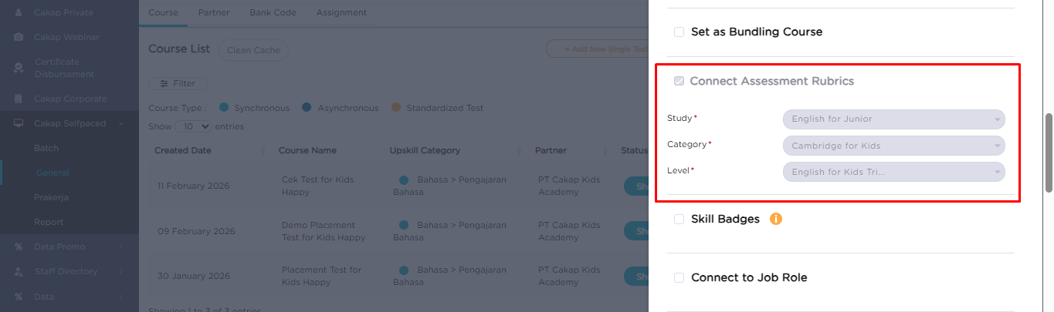
- Another difference is in the Material section. You need to manually check the option indicating that the material supports self-scheduling.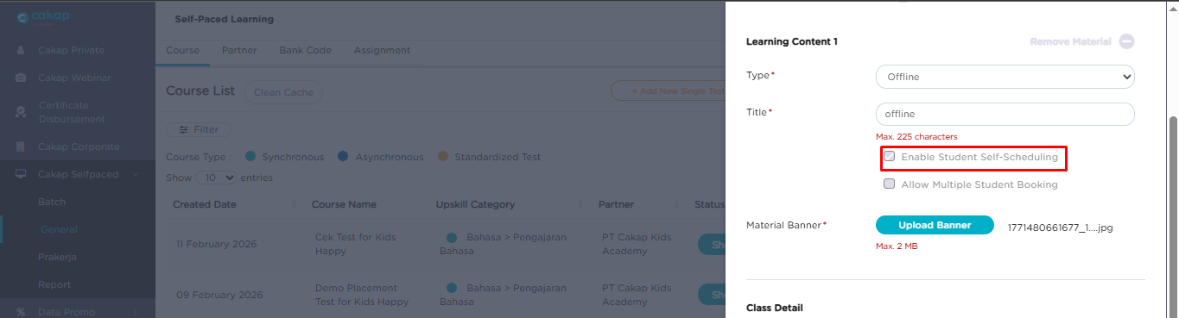

Admin Course Placement Test
Sample course : Demo [Kids] Final Exam Demo Cambridge For Kids - A1
- The method for creating the course is the same as the flow for creating an Admin Synchronous Course. The difference is in the Marketplace section, where you need to add the level. This is used for student booking to match the level between the teacher and the student. Also, check the option to support Kids if the course is for kids.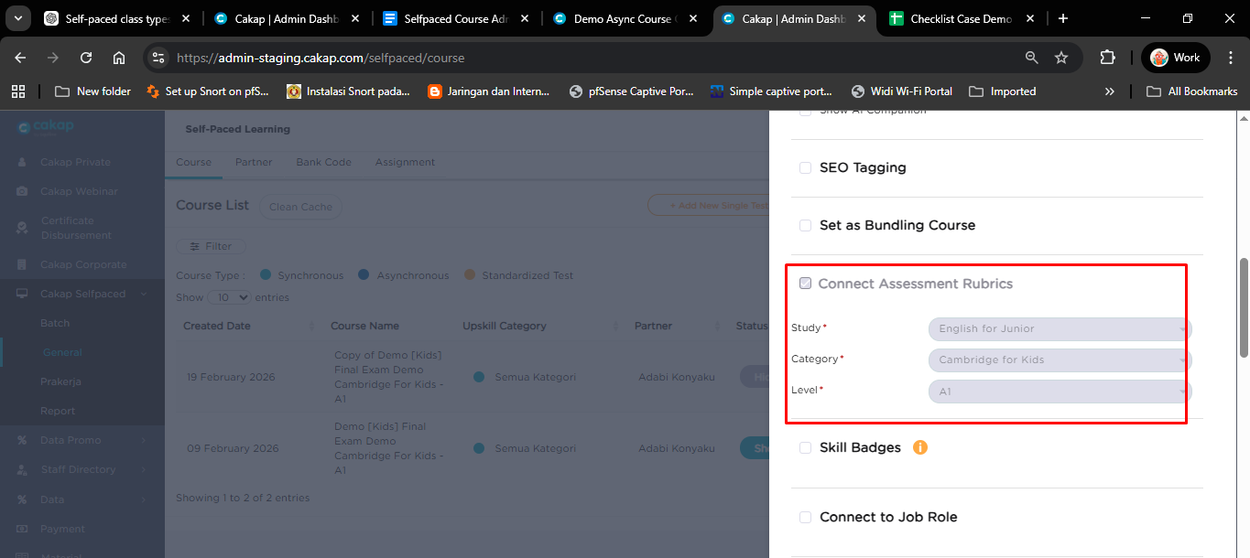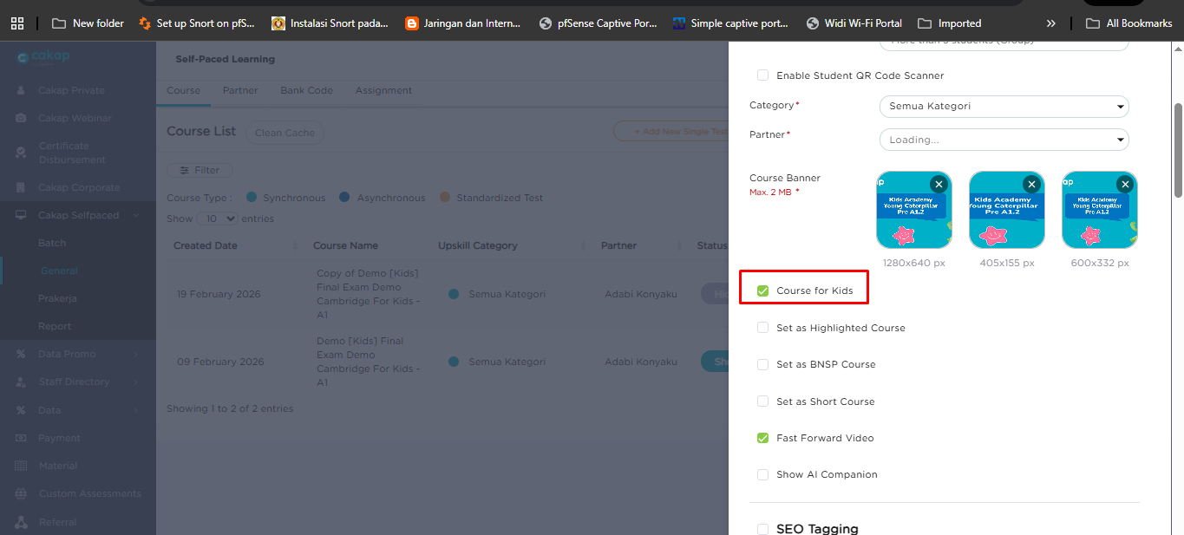

If the course type is a Synchronous Course, the admin needs to add a batch before students can redeem or purchase the course.
Create Batch In Admin
- Go to menu cakap selfpaced -> Batch -> Create New Batch -> Select course (Put the name course is has been created as synchronous course)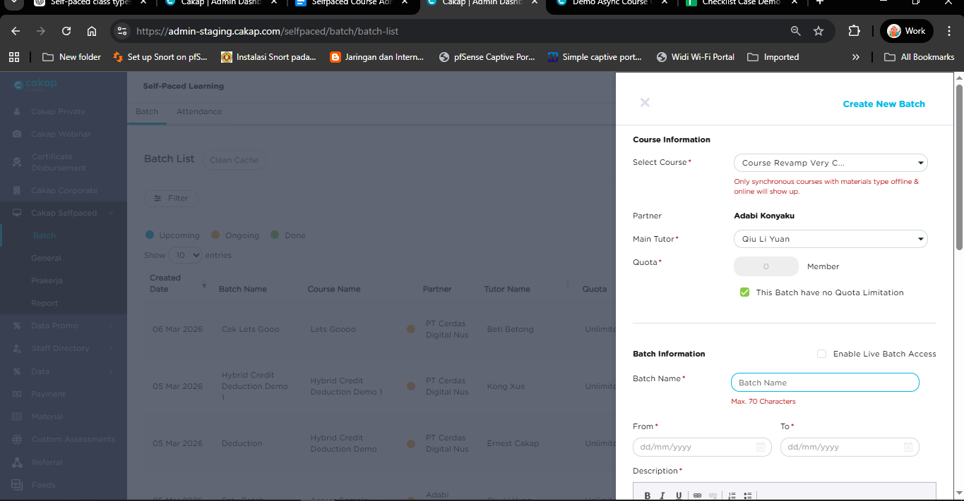
- Fill in all required fields in the Batch form.
- Add the schedule using either recurring or non-recurring (manual). Make sure the teacher’s schedule is available when opening the class and that it is not already booked by another class. Also ensure the teacher supports teaching Upskill. Scheduling can only be added for materials with the type Offline or Online. For the Class Placement Test, there is no need to add a class schedule, so you can skip this step.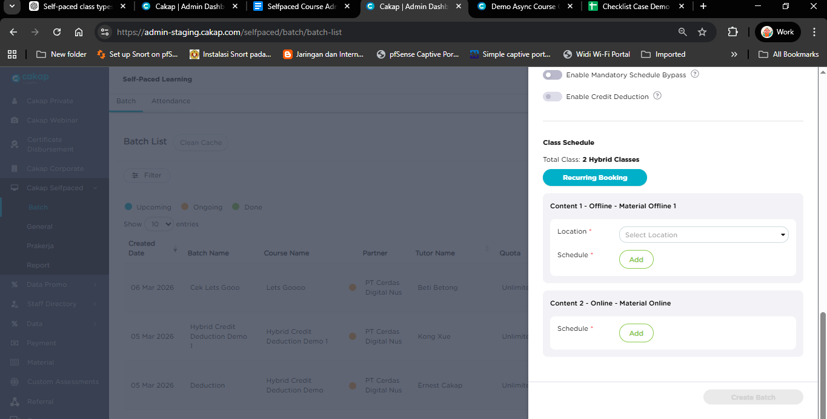
- Class Settings type in Batch
  - Enable Multi-Class Booking
When this option is enabled, the schedule in Batch 1 can be the same as the schedule in the next batch. This means multiple batches are allowed to share the same class schedule, so admins do not need to create different time slots for each batch.
  - Enable Mandatory Schedule Bypass
When this feature is enabled, the admin can create a batch without adding a schedule first. Normally, a schedule is required when creating a batch, but this option allows the batch to be created even if the schedule has not been set yet.
  - Enable Credit Deduction
This option is used only for Kids classes. When it is enabled, the student’s LMS credit will be deducted when the student selects or books a class schedule. The credit system ensures that students use their available credits to join or reserve a class session.
- Assign to teacher
  - Daily Report is used to support generating reports for the batch when students have redeemed or purchased the course. This feature helps track student activity and enrollment in each batch.
- If all the required fields have been filled in, the batch will be successfully created.

Generate Voucher Code From Selfpaced Menu
Students can redeem a code that has been generated by the admin as long as the code has not expired. Each voucher code is unique and can only be used by one user. A student cannot redeem multiple vouchers for the same course.
- Go to menu selfpaced -> General -> Search course -> Click icon blue generate code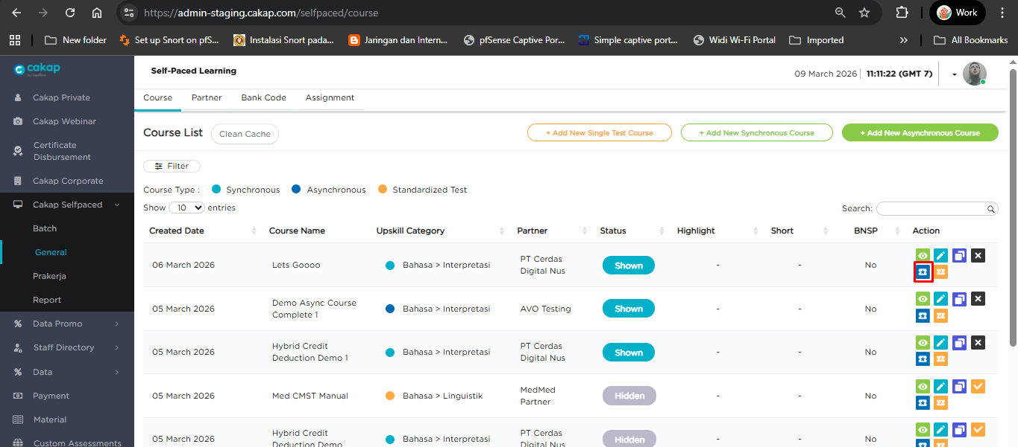
- Fill in all the required fields, set a long expiration time, then click Generate. The voucher codes will be automatically downloaded to your local device.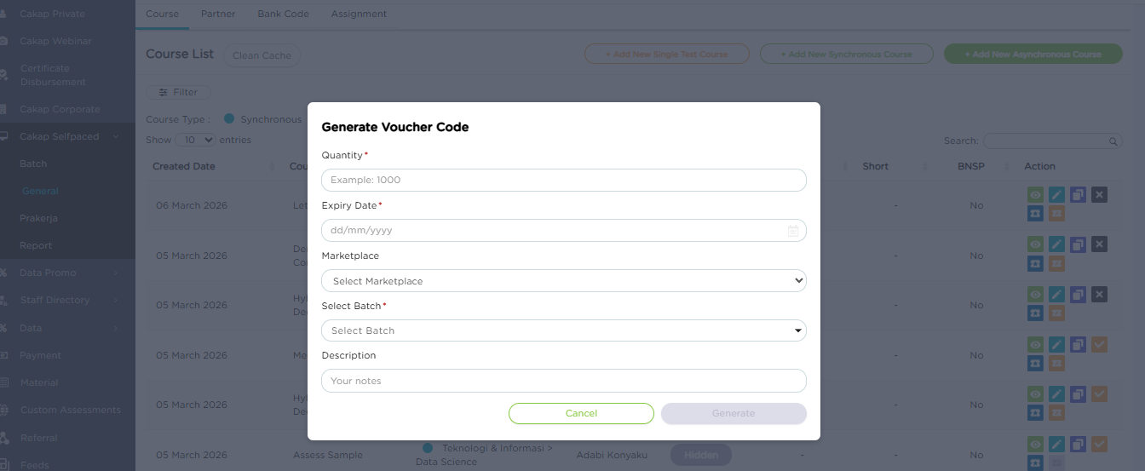
- Open the downloaded file and you will see the voucher codes that can be used in the LMS.